H.T No
Regulations:
A15

Sreenidhi Institute of Science and Technology
(An Autonomous Institution)
Code No: 5C735 Date: 18-Mar-2021 (FN)

B.Tech IV-Year I- Semester External Examination, March/April - 2021 (Supplementary)
Digital Design Through Verilog (ECE)

Time: 3 Hours Max.Marks:75

Note: a) No additional answer sheets will be provided.
b) All sub-parts of a question must be answered at one place only, otherwise it will not be valued.
c) Missing data can be assumed suitably.

ANSWER ANY 5 OUT OF 8 QUESTIONS. EACH QUESTION CARRIES 15 MARKS.

Bloom's Cognitive Levels of Learning (BCLL)

Remember | L1 | Apply | L3 | Evaluate | L5
Understand | L2 | Analyze | L4 | Create | L6

 |  |  | BCLL | CO(s) | Marks
1. | a) | Write short notes on the following lexical tokens.  (i)Scalars and Vectors (ii) Identifiers (iii) Keywords | L1 | CO1 | [8M]
 | b) | Describe the Verilog module and test bench structure with example. | L1 | CO1 | [7M]
2. | a) | Generate Verilog HDL source code and draw the logic diagram of a 2-to-4 decoder circuit. Give the data flow description. | L6 | CO2 | [8M]
 | b) | Explain the usage of generate construct in Verilog with suitable example. | L2 | CO2 | [7M]
3. | a) | List the various MOS switches available in verilog. Also explain with syntax and truth table. | L2 | CO3 | [8M]
 | b) | Design a 2-to-1 multiplexer using tristate gates  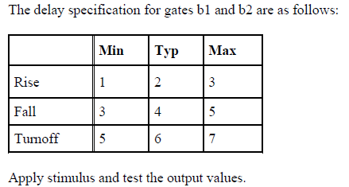 | L6 | CO3 | [7M]
4. | a) | Write verilog code for edge triggered D- Flip Flop with clear input using UDP. | L1 | CO4 | [8M]
 | b) | Explain function declaration and its invocation with examples. | L2 | CO4 | [7M]
5. | a) | What is the purpose of assertion verification? Explain in detail. | L2 | CO5 | [8M]
 | b) | Describe sequential circuit testing with examples. | L1 | CO5 | [7M]
6. | a) | Design a Dice game controller using Verilog HDL. | L6 | CO6 | [15M]
7. | a) | Write short notes on: (i) Simulation (ii) Synthesis | L1 | CO1 | [5M]
 | b) | Write a verilog code for n bit right-to- left shift register using behavioral model. | L1 | CO2 | [5M]
 | c) | Design a JK FF in gate level modeling. | L6 | CO3 | [5M]
8. | a) | Explain overriding parameters. | L2 | CO4 | [5M]
 | b) | Explain about flip-flop timing. | L2 | CO5 | [5M]
 | c) | Illustrate the ASM chart for binary a vending machine. | L4 | CO6 | [5M]

-- 00 -- 00 –

